The Evolution Northwest Wall at Khirbet el-Maqatir
Donald McNeeley
Abstract: Remnants of a Middle Bronze (MB) / Late Bronze (LB) fortress wall, identified as Wall 56 in the overall topographical plan survives in twelve squares (Q9-S13) in the northwest quadrant of Khirbet el-Maqatir (KeM). Excavations indicate that the MB/LB wall has gone through an evolutionary process of construction, abandonment, reuse by an Iron Age I occupation, abandonment, and reuse by a Late Hellenistic (LH) / Early Roman (ER) occupation. Three centuries after the LH/ER occupation destruction in AD 69 by the Tenth Roman Legion, this section of the wall became a location for throwing rocks plowed up by farmers. This paper will follow the evolution of the northwest fortification wall through the centuries.

Location
Khirbet el-Maqatir is approximately nine miles north of Jerusalem on the Central Hill Country Ridge of Israel. The Amorites chose a natural limestone hill on Wadi el-Gayeh’s south bank that rises to an elevation of ca. 890 m above sea level as a place to occupy, and ultimately, three additional cultural groups made the same choice. The site is located over a ridge located on the east side of the north-south road (Route 60), between an Israelite settlement and a Palestinian village and ca. 3 km east of ancient Bethel (Beitîn), as one travels north from Jerusalem to Shechem. In antiquity, an east-west road from Rabbah (Amman) in Transjordan ran past KeM on the north side of the site and through Bethel before terminating at the Mediterranean Sea, near Joppa (Fig. 1). Excavated soil and tumble depths ranging from less than 1 m in the Bronze Age Fortress to 2 m in the LH/ER town exist, while subterranean features of up to 2 m deep sometimes yield a total depth of 4 m.

Figure 1: Ancient Rabbah (Amman) to Joppa Road
The site today, as in antiquity, has exposed limestone bedrock. The exposed limestone was used ca. 100 BC to create a Late Hellenistic sketched plan (Fig. 2) of the LH/ER city excavated by the Associates for Biblical Research under the direction of Bryant Wood (1995-2000, 2010-2013) and Scott Stripling (2014-2016).
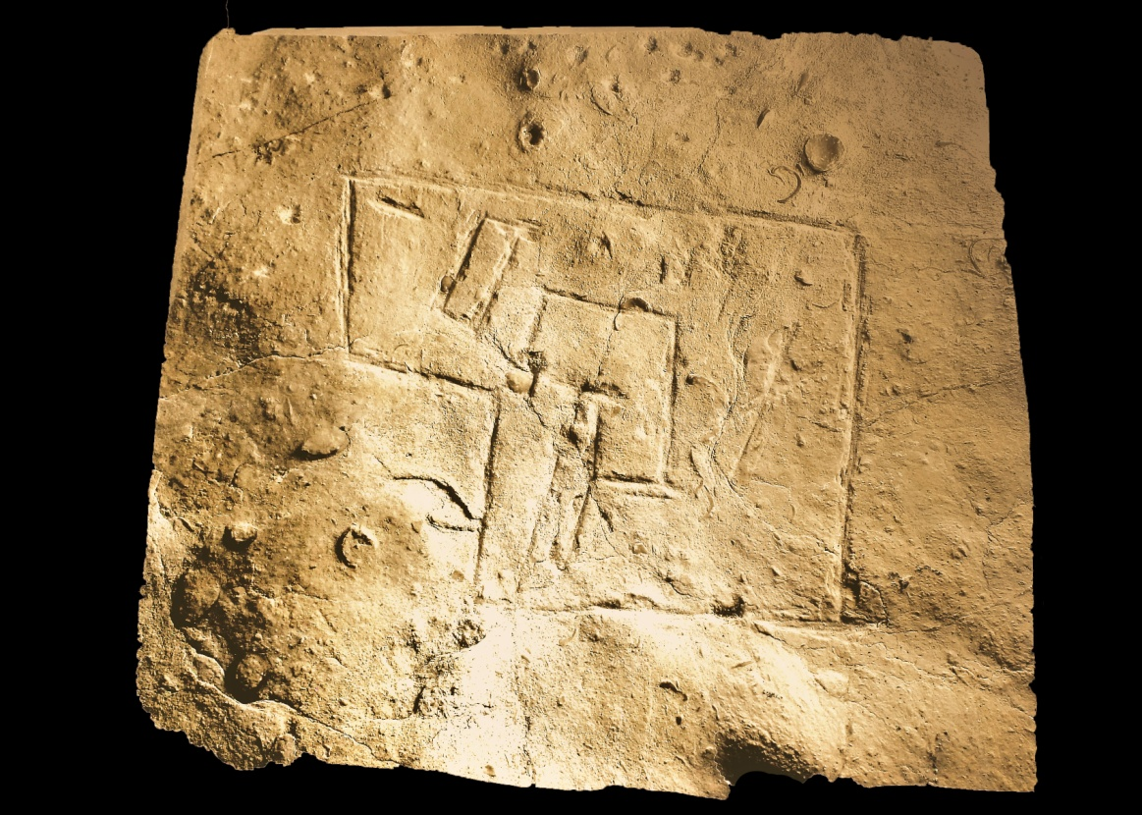
Figure 2: LH/ER City Map

Generic Occupational Information
Khirbet el-Maqatir boasts four occupation phases: an Amorite Bronze Age (MB III / LB I) presence, an Israelite presence during the Iron Age I (IA I), a Late Hellenistic/Early Roman (LH/ER) presence from the New Testament era, and a Byzantine presence. Recently (2015/2016), IA II and Persian artifacts have suggested some temporary presence during these ages, however, with no architectural evidence.
Nineteenth-century explorers including Robinson, Conder and Kitchener, Wilson, and Thomson documented the Byzantine complex. Victor Guerin first identified the four-acre LH/ER settlement while visiting the site in 1868. Excavations have yet to reveal any natural water source, and the abundance of cisterns indicates that the inhabitants were dependent upon stored rainwater or melted snow for hydration, though located 1.1 km away is a fresh water source from which water could have been transported in jugs to the site.

The Purpose of the Article
As noted above, various occupation levels are present on the site for fairly short periods of time from the Bronze Age to the Byzantine Period, with large occupation gaps over hundreds of years. Israel Finkelstein and Yitzhak Magen provided identification numbers for these occupational phases. The LH/ER remains were labeled Site 17–14/36/1 and the Bronze and Iron I remains were labeled Site 17–14/36/2. The Byzantine remains on the summit were not included in the surveys by Finkelstein. This paper ignores the Byzantine occupation located on top of the summit as only the Amorite MB/LB occupants, the Israelite IA I occupants, and the LH/ER occupants contributed to the evolving wall complex. Additionally, this paper will be limited to the perimeter walls in the northwest quadrant of the site (See Fig. 3).
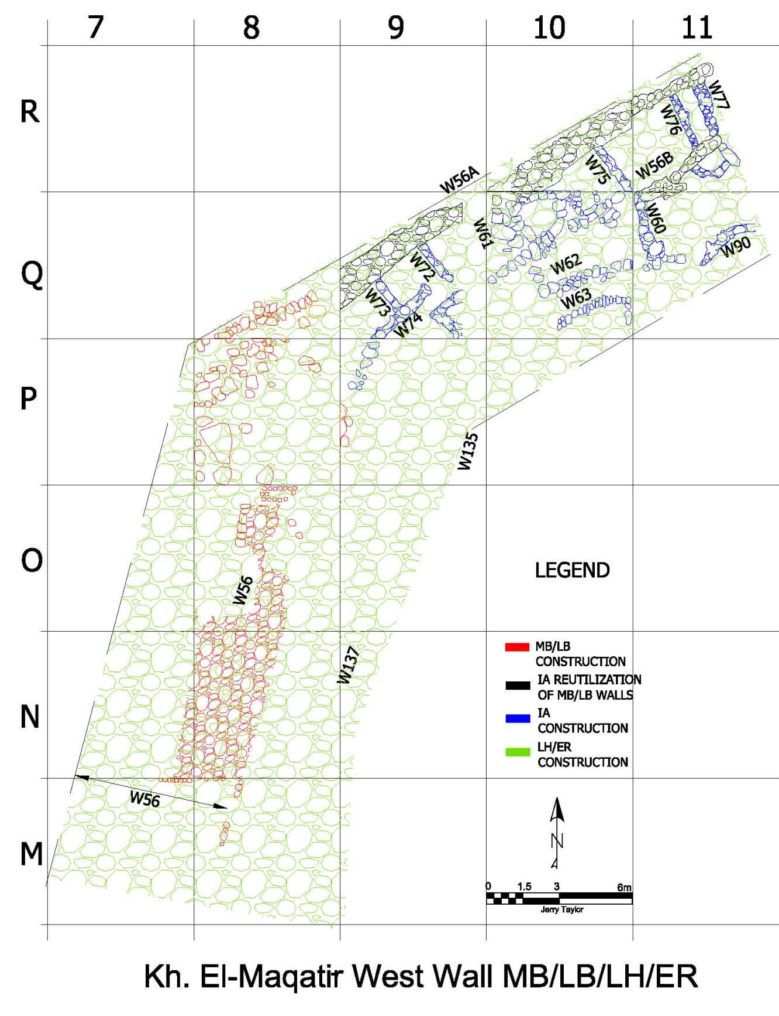
Figure 3: Northwest Wall Complex (drawn by Jerry Taylor)
As the following discussion will demonstrate, the Amorites erected a substantial wall in this northwest quadrant. IA I inhabitants utilized the Amorite wall which was then enhanced during the LH/ER period, resulting in an overall wall complex that aligned with the initial Amorite wall construction.

The Middle Bronze/Late Bronze Wall

Excavations at KeM produced a prolific amount of Middle/Late Bronze ceramics attesting to an MB/LB occupation when Amorites were inhabiting the highlands north of the Dead Sea. This people group build a curvilinear perimeter wall (Wall 56) placed directly on bedrock with a width ranging between 4-5 meters, with 1-7 courses remaining and multiple 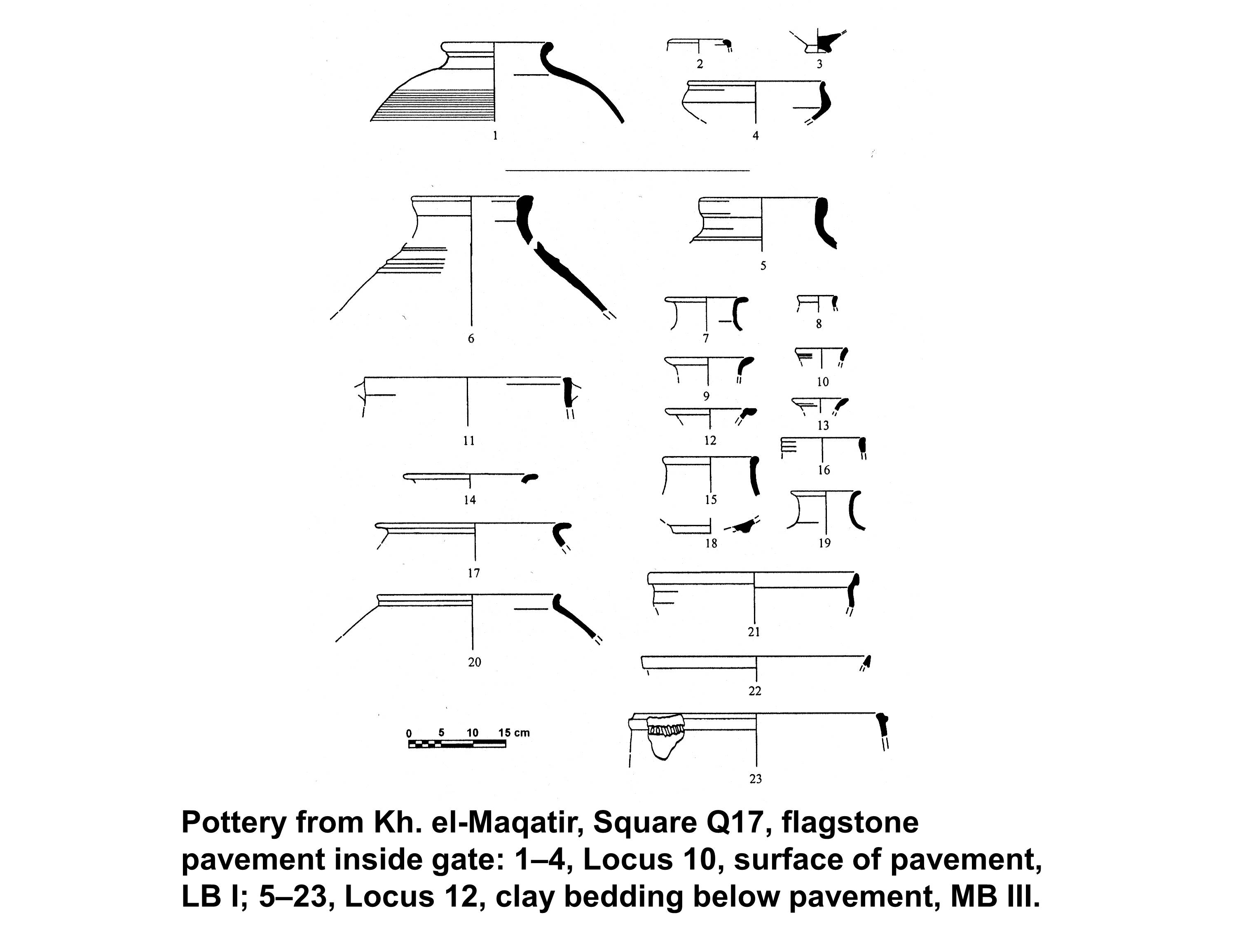
Figure 4: MB/LB Pottery (drawn by the author)
rows constructed with the following component measurements:
- 56A (an outer 1.1–1.2m structural support wall),
- 56B (an inner 0.3–0.7m structural support wall), and
- 56C (fill 2.6–3.1m between 56A and 56B).
This wall is similar to the Shiloh Middle Bronze fortification wall described as being "constructed of large field stones whose outer faces were occasionally slightly planed. ... the interior of the wall was filled with large and medium-size stones." This wall construction methodology is seen at Bethel (Beitîn, contra Livingston and others who propose el-Bireh) producing a wall which is 11 feet wide. As might be expected, the KeM Bronze Age wall has a similar wall as Beitîn that,
measured 11 feet thick .... Dr. Kelso and his staff were able to trace over 65 feet (20 meters) of the length of this ancient wall of Patriarchal Times, and discovered that it still survived to a height of over 10 feet. Before its partial destruction in Biblical times, it would have been considerably higher. Most city walls of Old Testament times stood at least 15 to 20 feet high, and many were likely 25 feet high."

Bethel's perimeter wall contained several gates, and it would be reasonable to expect a similar situation at KeM. While it is true that excavation revealed only one four chamber gate in the north wall area, a recent artistic rendering (2015) portrays a possible gate located between the two round towers on the south side of the (Fig.5). Unfortunately, the area where excavation would occur to validate a south gate is off limits due to an agricultural compound now used to grow olives.
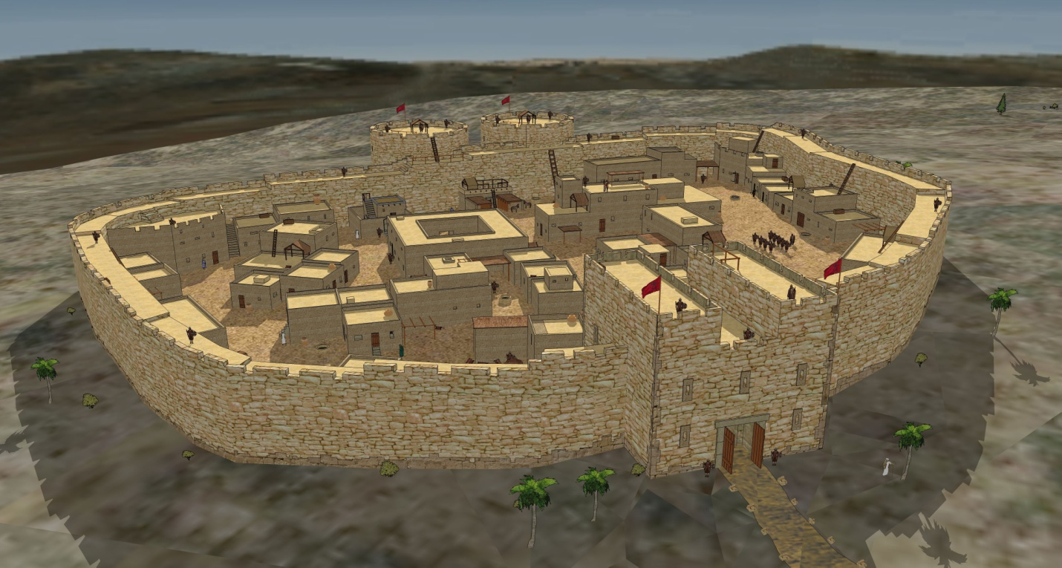
Figure 5: Proposed MB/LB Fort (drawn by Tom Miller)
Wood initially identified some wall structures in squares Q9 and R11 as a portion of an MB/LB wall during the 1999 season noting that:
In Squares Q9 and R11 well-preserved sections of the north wall were found. The wall here is 4.0 m (13 ft) wide, equal to the largest wall from that time period found in Israel! It would have stood to a height of some 12 m (40 ft)!
When excavating the wall to bedrock in 2000, it became evident that the outer wall segments in Q9 and R11, and an inner wall in R11 were from the MB/LB occupation period. At this time it was hypothesized that this wall was later reutilized during the Iron I occupation phase. Thus during the 2000 season, at a minimum, it was suggested that the Amorite wall sections in Q9 and R11 served at least two purposes: first, as part of the MB/LB fortification wall, and, secondly, as an IA I occupation village wall. Since 2010, traces of the MB/LB wall complex (Wall 56) have come to light as seen in Fig. 6. The missing portions of the wall, especially in squares O8, P8, and P9, could be associated with material utilization by later occupants (IA I, LH/ER). Moreover, the missing portions of the MB/LB wall in squares Q9, Q10, R10, R11, R12, and S12 are the result of the IA I occupation reutilizing this section and the material of the northwest wall for Israelite domestic structures to be discussed in the next section.
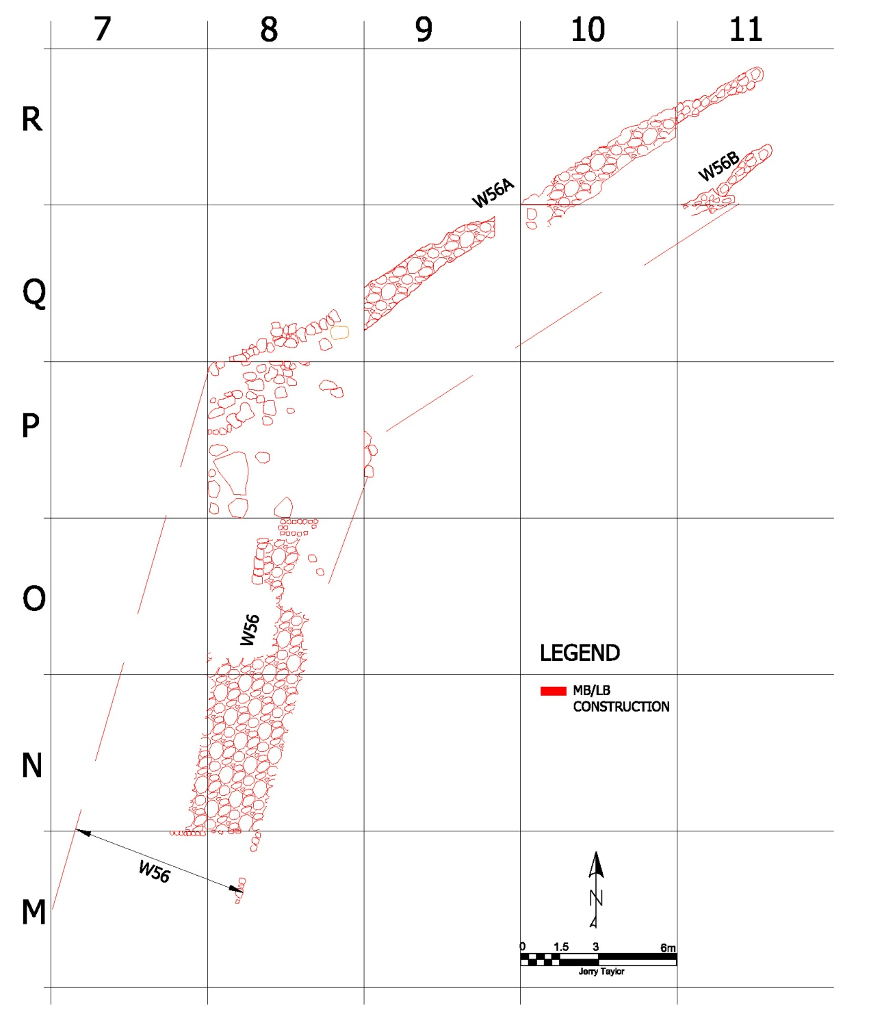
Figure 6: MB/LB Only Wall Complex (drawn by Jerry Taylor)

Iron Age Walls

The settlement pattern in the central hill country during IA I changed significantly from that seen in the Late Bronze Age. Mazar notes that there was "a proliferation of small settlements established in parts of the highlands which had not been previously settled." This pattern is similar to that at KeM with occupation structures that intruded into the northern wall. Wood suggests that "These new occupants were most likely Israelites, as the Israelites dominated the central hill country at that time."

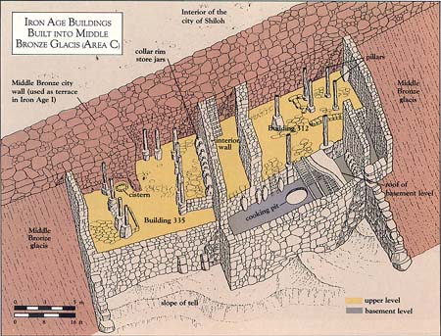
Figure 7: "Sunken House" by Leen Ritmeyer
These domestic buildings were constructed through either utilization of the existing MB/LB walls (W56A and W56B) or by pillaging the material from the MB/LB wall fill to construct walls W61, W62, W63, W72, W73, W76, W77, and W90 (Fig. 8). As of the 2015 season, excavated IA I structures in Squares Q9, Q10, Q11, and R11 in the northwest quadrant were deemed similar to buildings at Shiloh looking as if they, as Finkelstein states, are "actually 'sunken' into the Middle Bronze" wall (Fig. 7). Bunimovitz, who authored the Iron I presence in Area C section in Shiloh: The Archaeology of a Biblical Site, states that "The buildings we excavated here were erected outside the perimeter of the Middle Bronze fortification wall, which was well preserved here and served as the rear wall of these buildings." In Area H at Shiloh, there are two Iron Age rooms that were built into the MB/LB wall by removal of the fill (Fig. 8). In all three cases, reutilization of the MB/LB wall structure is evident. As an aside, 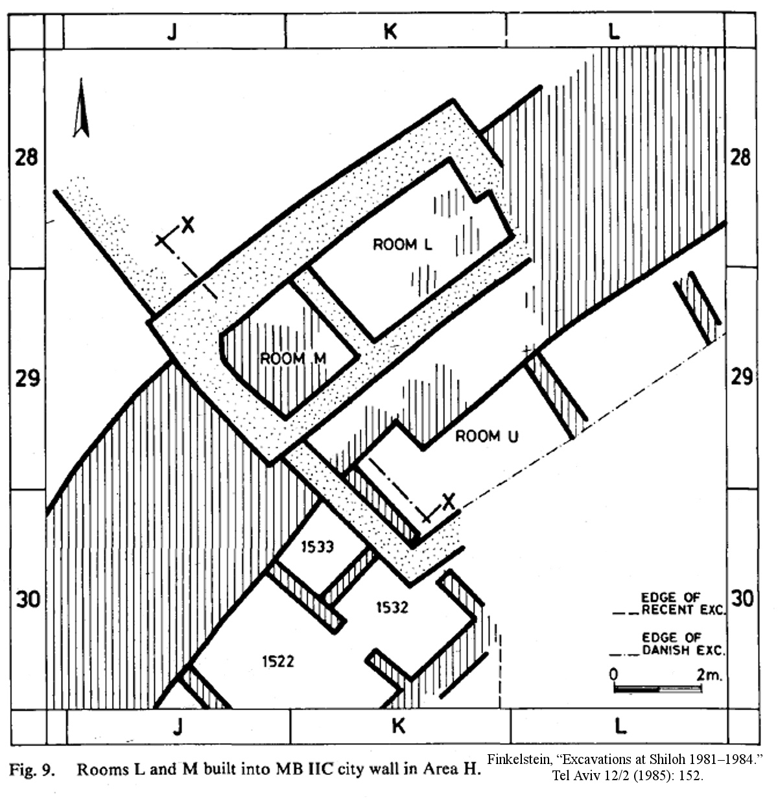
Figure 8: Rooms L and M built into the MB IIC city wall.
the Iron I complex at KeM lends support to a four-room house theory. The theory is that the most likely development of the "four room house" plan, was "from the simple broadroom, through the broadroom with courtyard beside it, to the standard form of this building with its characteristic components." This is based on the "idea that we must look to the nomad's dwelling - the tent or the hut - for the origin of this house plan (sic four room house) ... seems eminently reasonable." If this is true, at KeM, we have an example of the broadroom with a courtyard with its areas for caroling animals and domestic activities (Fig. 9).
In 2016, additional house structures were identified in squares Q12, R12, R13, S12, and S13 exposing the entire extent of the IA I structures starting in Q9 and continuing along the MB/LB exterior wall to S13. The domestic structures identified in 2015/2016, together with the previously identified structures, create a grouping of rooms as seen in Fig. 10. These poorly constructed stone walls (W60, W75, etc.) bonded with the more massive MB/LB walls (W56A) were one stone wide and seemed to lack any mortar, being dry laid directly on bedrock. The KeM structures 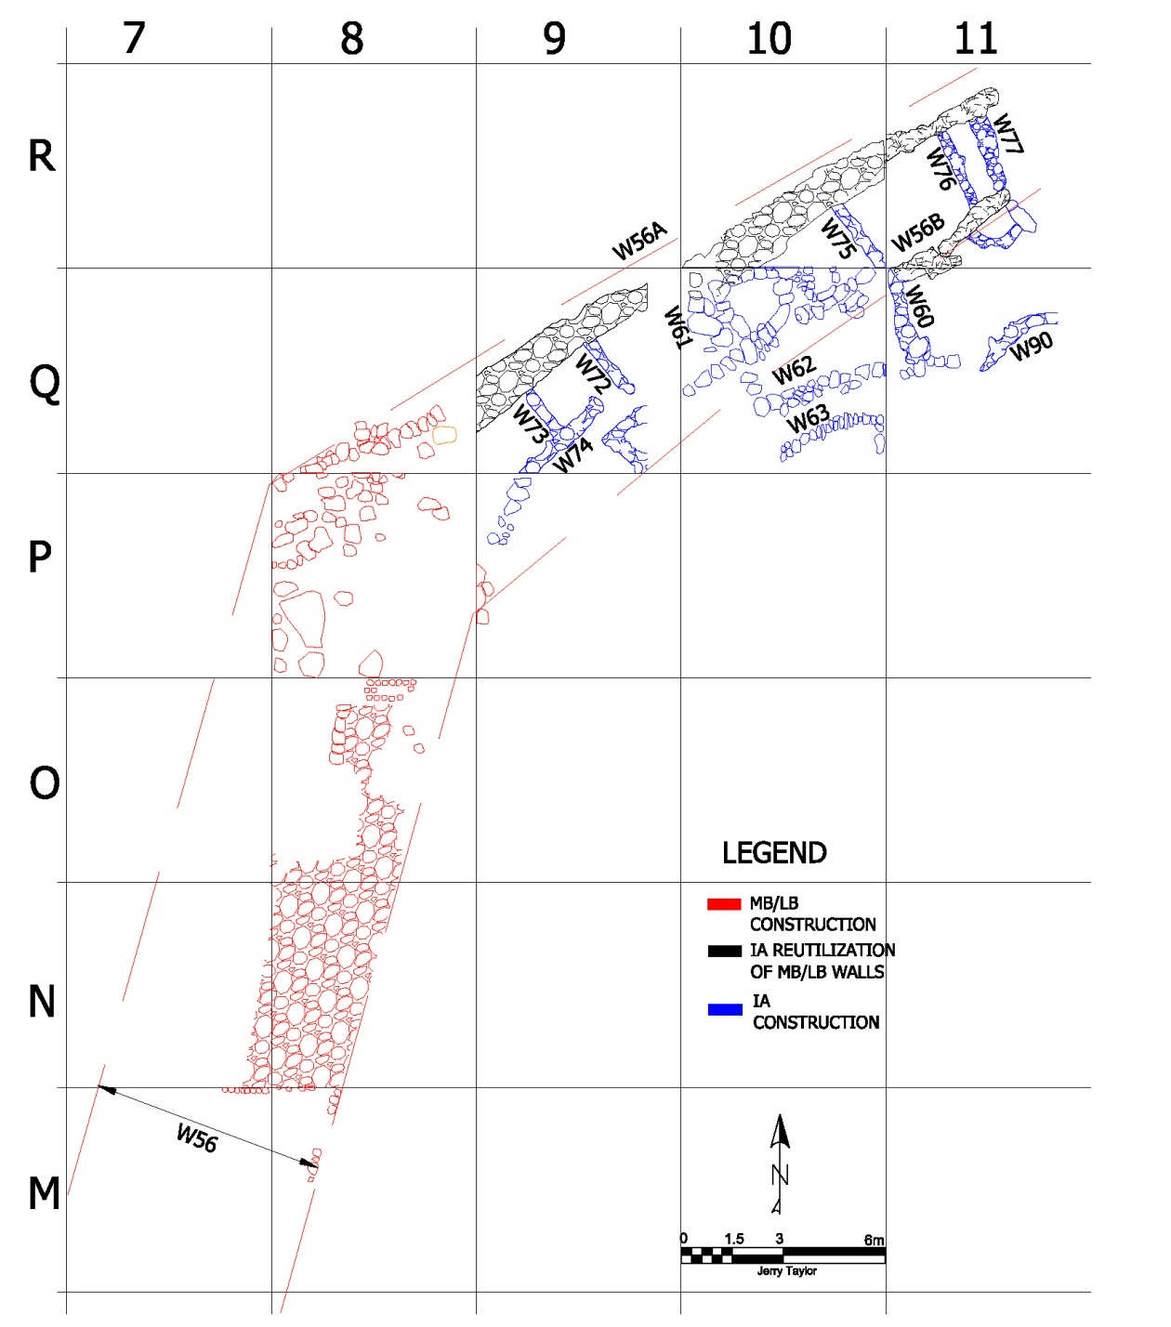
Figure 9: Top plan with IA Domestic Intrusion (drawn by Jerry Taylor)

Figure 10: Artistic Depiction of the IA Domestic Structures (drawn by Leen Ritmeyer)
correspond nicely with a description by Larry G. Herr and Douglas R. Clark where "domestic structures, some bonded to the perimeter wall. ... are still standing, in some places to a height of 8 feet (KeM Wall W60 measured .9 m high approximately three feet)." Figure 10 depicts an artistic rendering of these domestic structures. Herr and Clark continue by stating that:
The stones ranged from small field stones to large boulders; they had been either transported from the surrounding slopes or reused from earlier structures (emphasis by author) at the site. The wall was chinked with cobbles to give it more stability. Raouf Abujaber, a local historian and landowner, estimates that it would take four men and a donkey about a month of intensive labor to collect the stones and to erect the first-story exterior walls. The interior walls and the animal pen would take another week. The stones in the walls weighed more than 280 tons.
Albright commenting about these architectural features states that "this intrusion of IA I/II architectural features was part of an unfortified gathering of permanent dwellings with storage facilities of silos, cisterns, and very large pithoi."
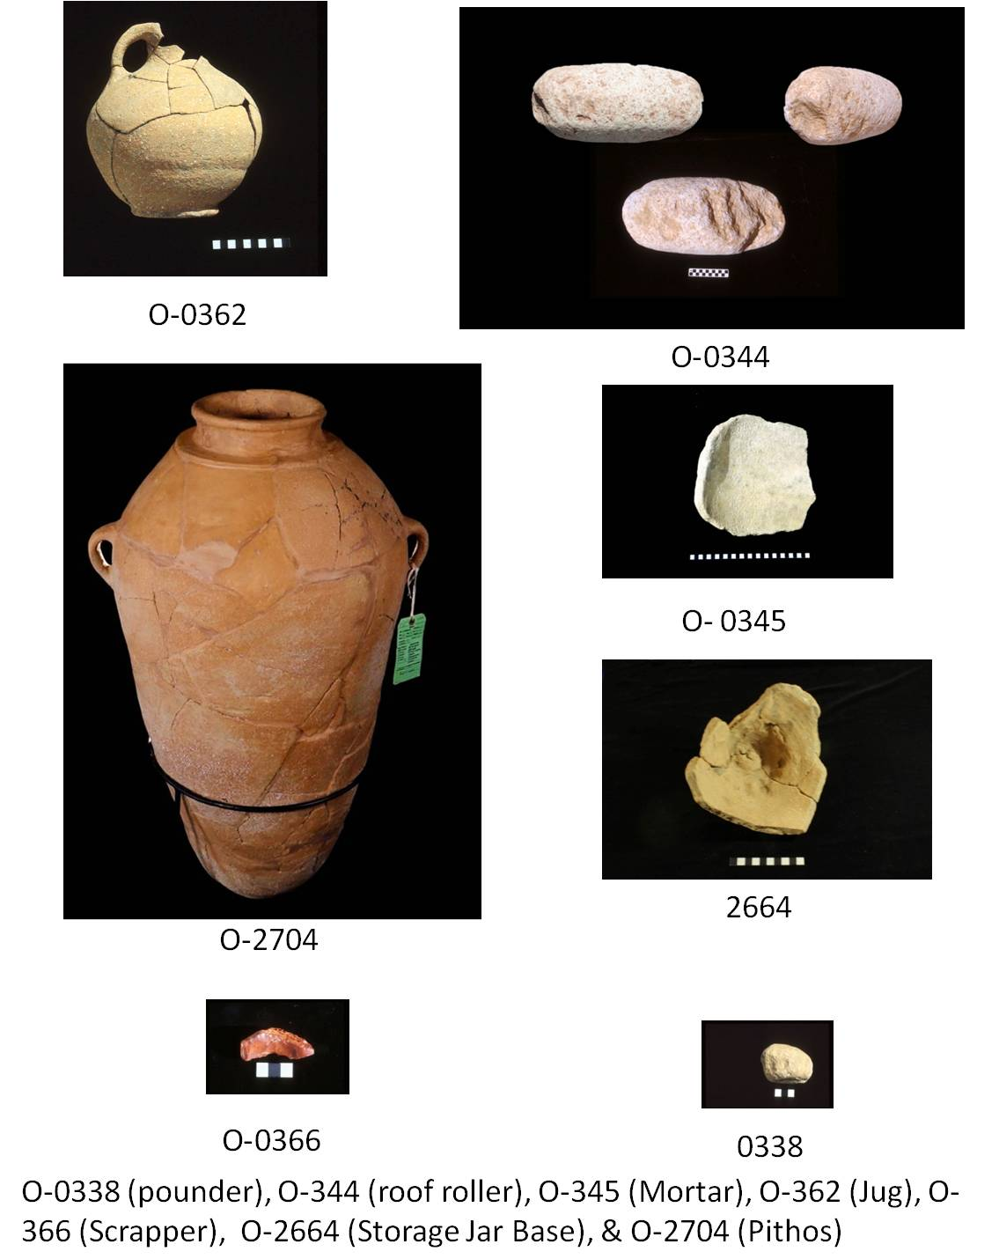
Figure 11: IA Domestic P9-S13 Examples (Object O-2704 by Mark Henderson; all other photos by Mike Luddeni)
The existing IA I walls at KeM are simplistic and as noted earlier could be seen as prototypes of the typical IA I four-room house walls identified at other sites. The floors in the subject squares (P9-S13) were composed of hard-packed clay and revealed a multitude of domestic items excavated (Fig. 11) during the 2012-2016 seasons. Mazar suggests that an "assemblage of cultural artifacts such as this indicates that these inhabitants came from an agricultural culture, rather than some type of nomadic background." Additional IA I architectural features have been found beneath the LH/ER remains to the east of the Northwest wall which will be a continual topic of discussion.
If the occupants were from an agricultural culture, as indicative from the artifacts, it is possible that these inhabitants used terrace farming techniques around the northwest wall, re-utilizing material from the MB/LB wall construct. According to Mazar, "terraces are located on the slopes of hills (known as ‘lateral’ or ‘contour’ terraces), on sloping plateau areas (known as ‘enclosure’ terraces), and across gullies and in valleys (known as ‘cross-channel’ terraces or ‘check dams’)." Since the overall slope of the area surrounding the northwest wall is a gentle 10–11 degrees, enclosure/ broad-based terraces would be required, but only if a large area was needed to support extensive farming. These "Broad-based terraces are designed to be entirely farmed; they are generally suitable for long, uniform gentle slopes of up to 6% or so;" a situation that is not apparent at KeM. As a cultural indicator, Finkelstein in his presentation "When Did the Jewish People Begin?" states that terracing should be ignored as an indicator for IA I presence. Thus the lack of terraces does not hinder the identification of these domestic habitations as belonging to the IA I/II cultural environment. The bottom line is that there just does not seem to be any terraces during the IA I/II period.
A small enclave of Israelites occupied the site for some time, but ultimately the site was abandoned. The domestic and other structures were slowly reclaimed by nature and maybe played host to wandering bands of people during the Iron II and Persian periods.

LH/ER Walls

Initially, the top level debris removed from various squares in the northwest quadrant was assumed to be post LH/ER agricultural efforts where farmers tossed stone debris on top of the IA I buildings that when abandoned formed a series of nice holding bins for the rocks. During the 2000 dig season, however, it was suggested that the fill might also be a Hasmonean construct. The 2010 season validated this concept when an east-west probe trench across squares M7, M8, and M9 revealed the extent of the MB/LB wall in that section of the wall. As seen in the M8 square drawing (Fig 12), the MB/LB wall was preserved to a width of 3.7 m at its base,
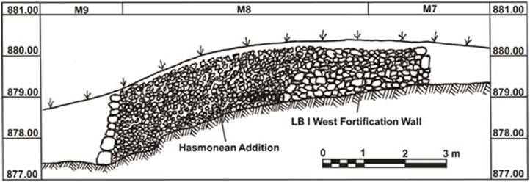
Figure 12: Profile of Hasmonean Wall Overlay (drawing by Suzanne Lattimer)
similar to the width of the MB/LB wall identified in the 1999 season. This wall was abutted by a massive additional wall construction, to the east, determined to be associated with the Hasmonean period of occupation. Thus, if the LH/ER wall continued into the Q9-S13 squares, the LH/ER fill covered an assemblage of IA I domestic material in the IA I spaces that had been carved out of the earlier MB/LB wall (Fig. 13).
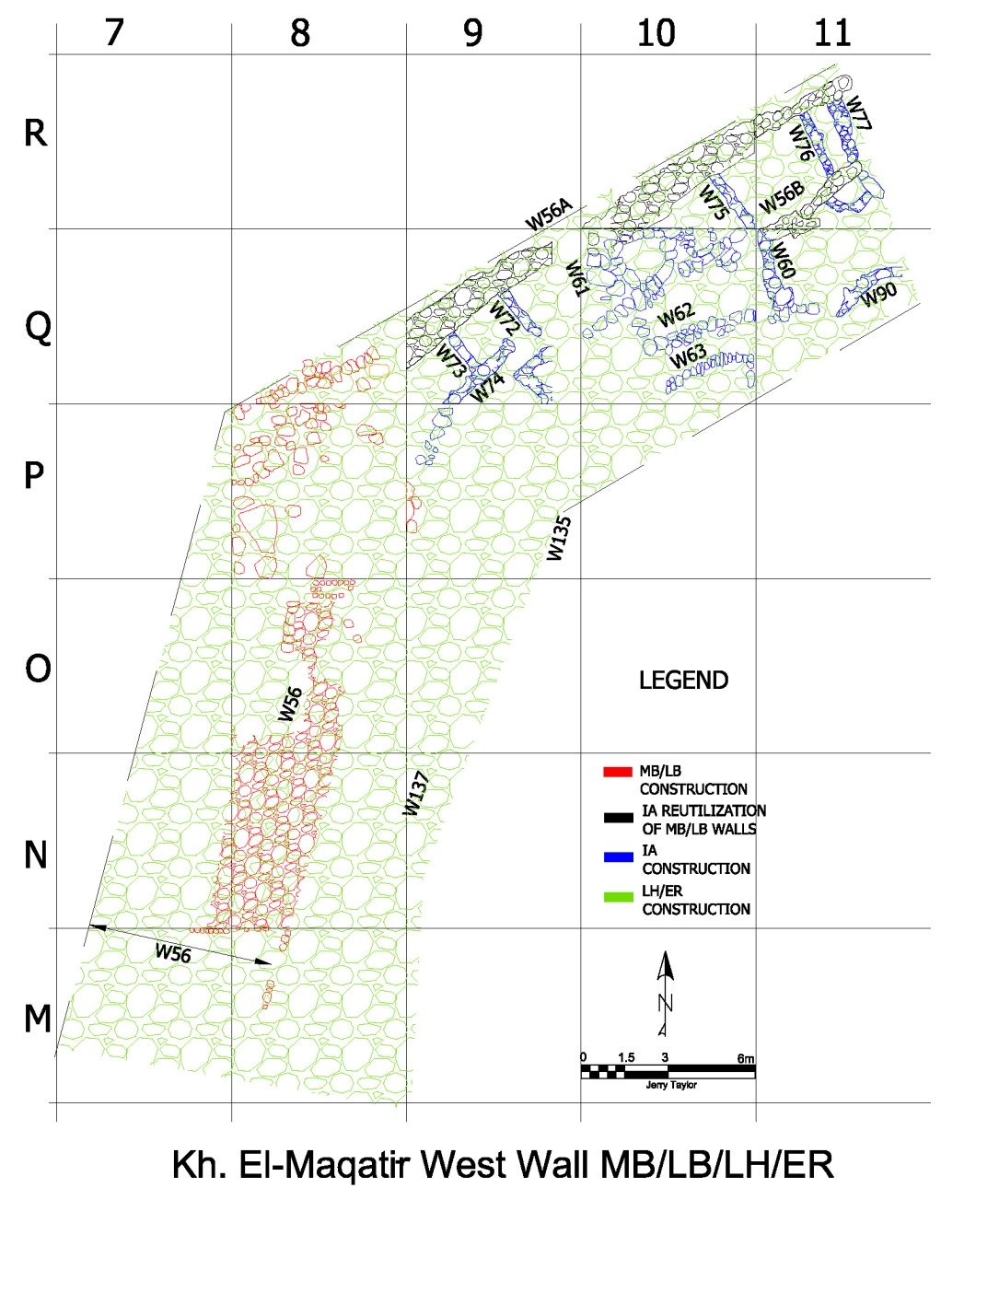
Figure 13: All wall phases (drawn by Jerry Taylor)
Additionally, as mentioned earlier, Hasmonean architects developed a settlement plan (see Fig. 2) for the construction of an LH/ER town. While most of the town, as of the 2016 season, seemed to be primarily located in the northeast quadrant of the site, as indicated earlier, there is evidence of an LH/ER wall-like construct within the northwest quadrant. This construct, built on top of the existing MB/LB wall and IA I remains, was extended by approximately an additional 4.7m wide wall that some have considered to be a terrace wall. Wood describes this terrace wall thus: "To the east is a stone fill, or terrace, 4.7 m (15 ft) wide which runs parallel to the inside of the western wall (Wall 56). In 1998 the retaining wall for this 'terrace' was traced for a distance of ca. 40 m (130 ft). The terrace evidently was built on the sloping west side of the fortress to provide a foundation for the ring road." At a minimum, this wall extends northeastward from squares M7, M8, and M9 towards the MB/LB fortress gate complex in squares R16-T20 (Fig. 12) and runs through the P9-Q13 squares covering the MB/LB wall and the IA I domestic structures in those squares.

Summary
For almost 1700 years the northwest wall and, by extension, the entire perimeter wall at KeM provided a firm foundation for three distinct people groups. The Amorites built and utilized the wall for fortification purposes and established the initial layout of the wall during the MB/LB period. After the abandonment of the city sometime in the Late Bronze period, the wall was available for the next group to use the wall for their purposes. During the Iron I period a group of Israelites saw the wall as a perfect construction site for their domestic buildings; utilizing the material from the wall and used the outer wall as part of their new homes as another Israelite group had done at Shiloh. This group ultimately moved on and abandoned the northwest wall until sometime in the Late Hellenistic period a new village was built. Again, as before the northwest wall was utilized by this group of settlers as a foundation for a terrace wall to provide a foundation for a ring road that surrounded the village. Even in modern times, the remains of wall provided a dumping ground for rocks removed from tilling the land for farming purposes.

Bibliography

Albright, W. F. The Archaeology of Palestine. Baltimore: Penguin Press, 1960).

Amihai Mazar, Studies in the Archaeology of the Iron Age in Israel and Jordan, vol. 331, Journal for the Study of the Old Testament Supplement Series (Sheffield, England: Sheffield Academic Press, 2001).

Clark, Douglas R., "The Four-Room House: What It Took to Get It Built," Biblical Archaeology Review, Volume 27, #2 (2001).

Finkelstein, Israel, "Patriarchs, Exodus, Conquest: Fact or Fiction?" video of presentation at the International Institute For Secular Humanistic Judaism, Colloquium '05 - Digging for the truth, Archaeology and the Bible.

Guerin, Victor H., Description Geographique, Historique et Archeologique de la Palestine, Premiere Partie, Judee, Tome Troisieme.

Herr, Larry G. and Douglas R. Clark, "Excavating the Tribe of Reuben" Biblical Archaeology Review," Volume 27, #2, Biblical Archaeology Society, (2001).

Shanks, Hershel, ed., Biblical Archaeology Review 12:01 (Jan/Feb 1986), Biblical Archaeology Society, 1986).

Stripling, Scott, “Khirbet el-Maqatir: A Biblical Site on the Benjamin-Ephraim Border,” ed. Richard Lanser, Bible and Spade 30, no. 3 (2017) pp 32-37.

Wood, Bryant, "Kh. el-Maqatir 1998 Dig Report," Bible and Spade 12:4, Associates for Biblical Research, (1999).

Wood, Bryant, "Kh. el-Maqatir 1999 Dig Report," Bible and Spade Volume 13:3, Associates for Biblical Research, (2000).

Internet ... http://www.mda.state.mn.us/protecting/conservation/practices/terrace.aspx on 9 October 2015

Stripling, Scott, “Khirbet el-Maqatir: A Biblical Site on the Benjamin-Ephraim Border,” ed. Richard Lanser, Bible and Spade 30, no. 3 (2017), 32-37.
Guerin, Victor H., Description Geographique, Historique et Archeologique de la Palestine, Premiere Partie, Judee, Tome Troisieme, 57.
Finkelstein, Israel, Zvi Lederman, and Shlomo Bunimovitz, The Highlands of Many Cultures, the Southern Samaria Survey: The Sites, (1997), 521–522.
Hershel Shanks, ed., BAR 12:01 (Jan/Feb 1986) (Biblical Archaeology Society, 1986).
Near Eastern Archaeology: Bulletin of the Near East Archaeological Society 1, no. 4 (1958).
Wood, Bryant, "Kh. el-Maqatir 1999 Dig Report,"Bible and Spade 12:4 (1999), 100–111.
Amihai Mazar, Studies in the Archaeology of the Iron Age in Israel and Jordan, vol. 331, Journal for the Study of the Old Testament Supplement Series (Sheffield, England: Sheffield Academic Press, 2001), 126.
Wood, Bryant. "Kh. el-Maqatir 2000 Dig Report", Bible and Spade, Volume13:3 (Summer) 2000.
Hershel Shanks, ed., BAR 12:01 (Jan/Feb 1986) (Biblical Archaeology Society, 1986).
Bunimovitz, Shlomo, "Area C: The Iron Age I Pillared Buildings and Other Remains." Shiloh: The Archaeology of a Biblical Site, 2nd addition, Finkelstein, Israel, ed., Tel Aviv University, Tel Aviv, Israel, 2011, 7.
Shiloh, Yigal. "The Casemate Wall, the Four Room House, and Early Planning in the Israelite City." Bulletin of the American Schools of Oriental Research, no. 268 (1987, 3–15.
Shiloh, Yigal. "The Casemate Wall, the Four Room House, and Early Planning in the Israelite City." Bulletin of the American Schools of Oriental Research, no. 268 (1987), 3-15.
Herr, Larry G. and Douglas R. Clark, " Excavating the Tribe of Reuben" Biblical Archaeology Review," Volume 27, #2 (2001), 44.
Clark, Douglas R., "The Four-Room House: What It Took to Get It Built," Biblical Archaeology Review, Volume 27, #2 (2001), 43.
Albright, W. F. The Archaeology of Palestine. (Baltimore, Penguin Press, 1960), 113.
Amihai Mazar, Studies in the Archaeology of the Iron Age in Israel and Jordan, vol. 331, Journal for the Study of the Old Testament Supplement Series (Sheffield, England: Sheffield Academic Press, 2001), 126.
Ibid, 114.
Internet ... http://www.mda.state.mn.us/protecting/conservation/practices/terrace.aspx on 9 October 2015
Finkelstein , Israel, "Patriarchs, Exodus, Conquest: Fact or Fiction?" video of presentation at the International Institute For Secular Humanistic Judaism, Colloquium '05 - Digging for the truth, Archaeology and the Bible.
Wood, Bryant. "Kh. el-Maqatir 2000 Dig Report", Bible and Spade, Volume13:3 (Summer) 2000, 69.

